When you first launch Wireshark a welcome screensimilar to the one shown above should be visible,

containing a list of available network connectionson your current device.

In this example, you'll notice that the followingconnection types are shown: Bluetooth Network Connection, Ethernet, VirtualBox Host-Only Network, Wi-Fi.

Displayed to the right of each is an EKG-style line graph that represents live traffic on that respective

network.

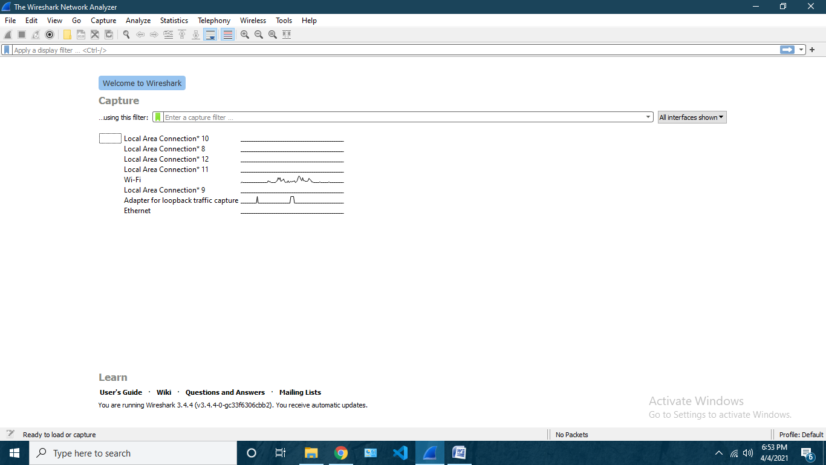To begin capturing packets, first select one or moreof these networks by clicking on your choice(s)

As soon as you click the interface’s name, you’ll see the packets start to appear in real time. Wireshark

captures each packet sent to or from your system.

Click the red “Stop” button near the top left cornerof the window when you want to stop capturing traffic.

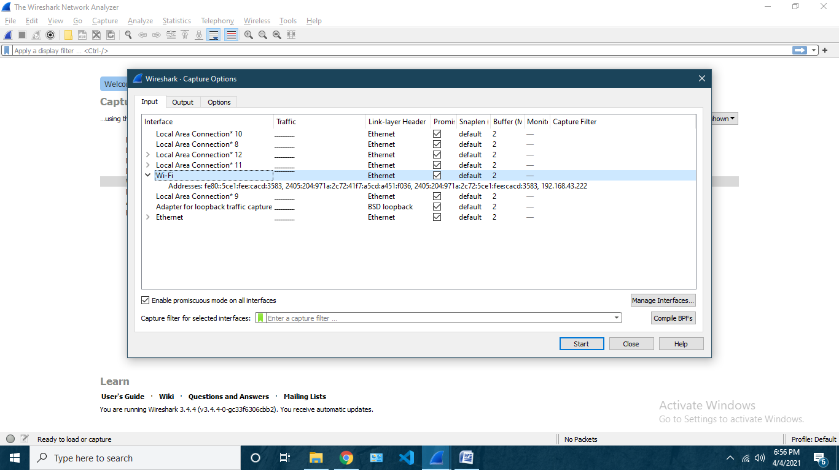

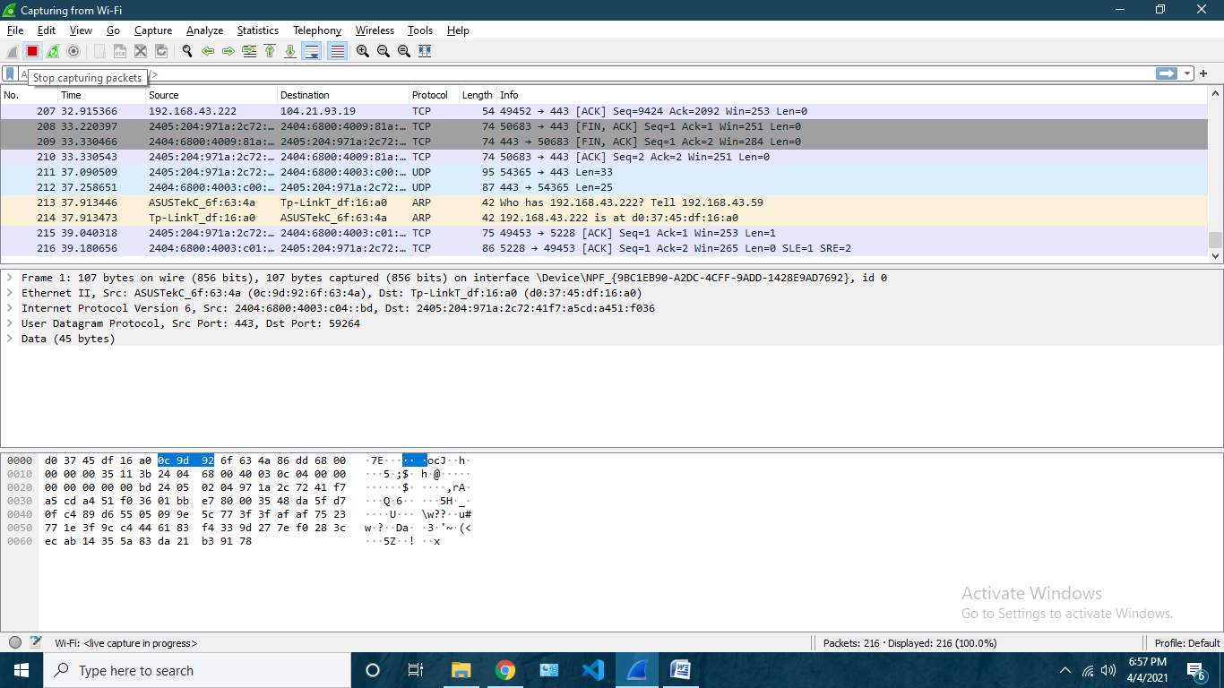

**ICMP Packets**

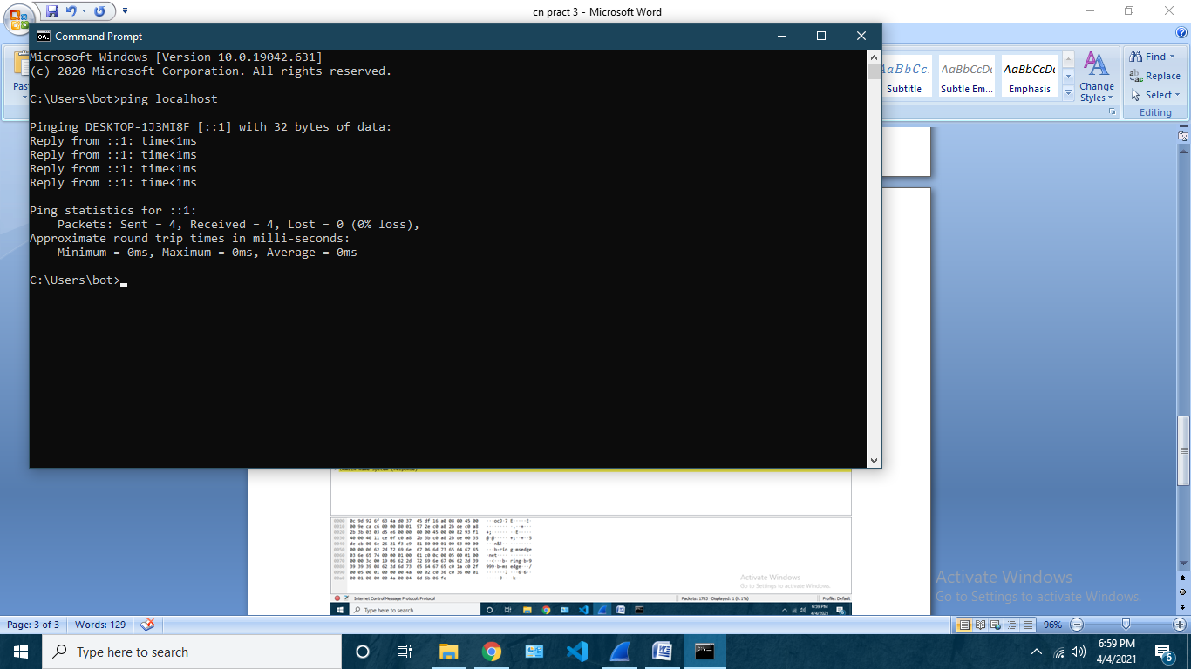

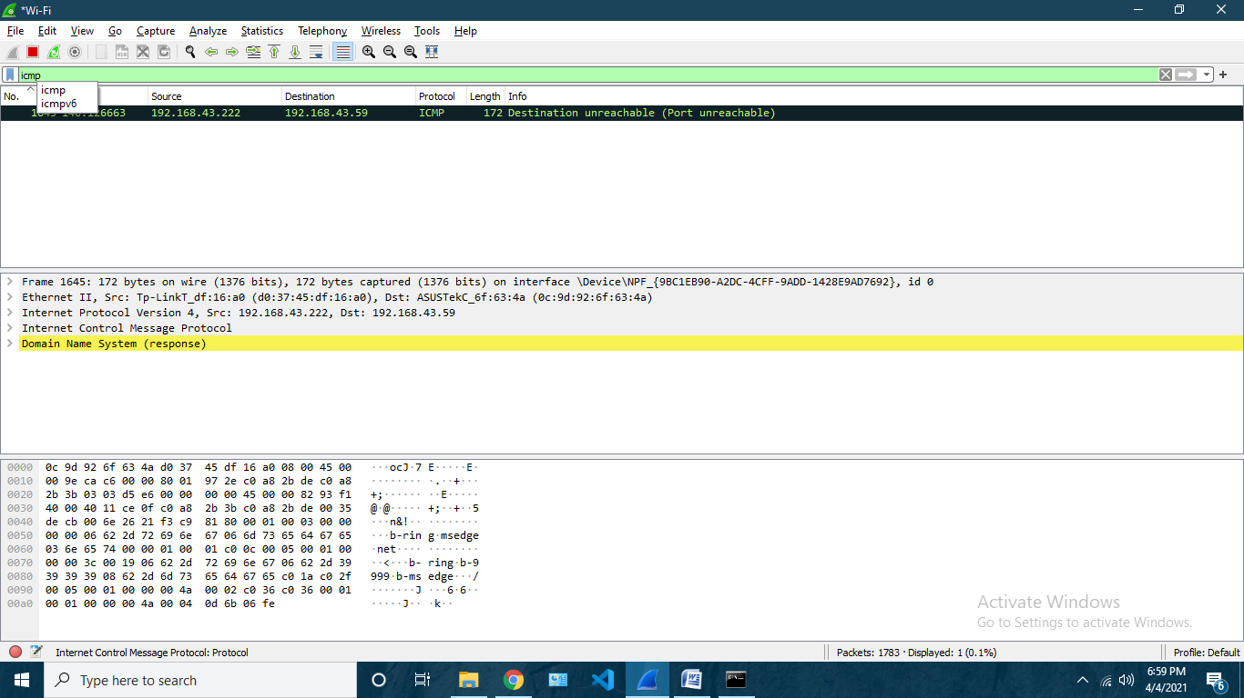

**TCP**

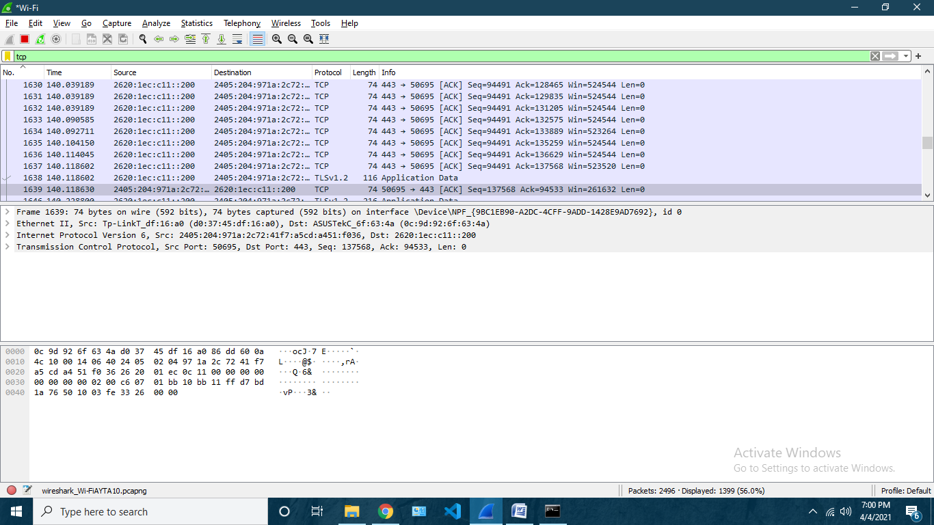

**HTTP**

To send http packets send packets by hosting a live server on localhost I did this using vs code

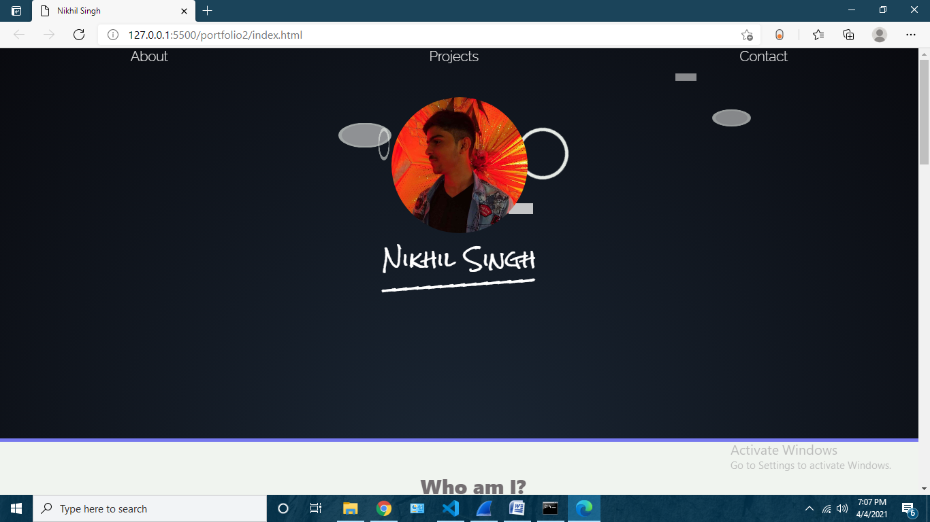

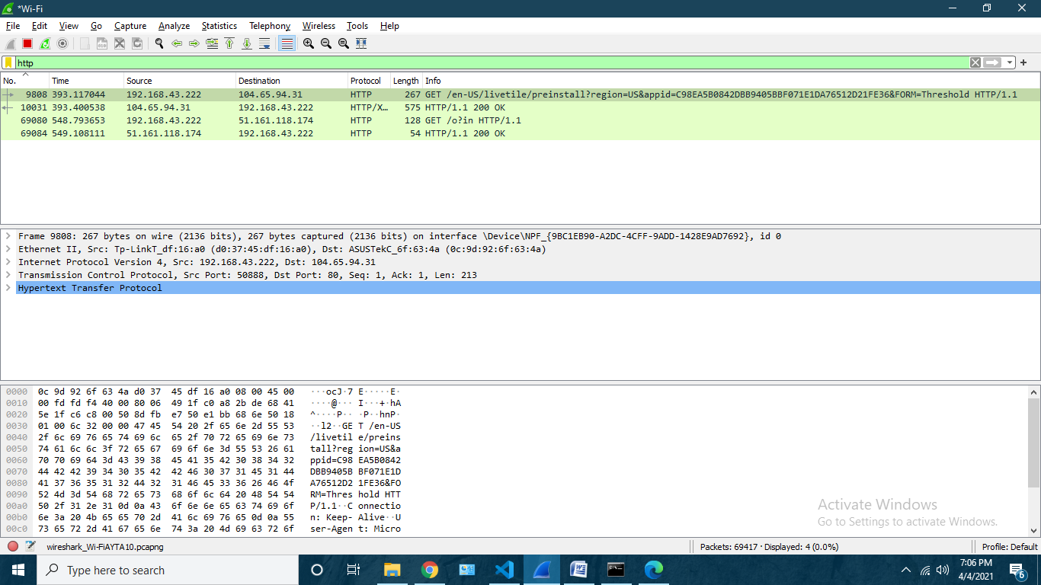

**UDP**

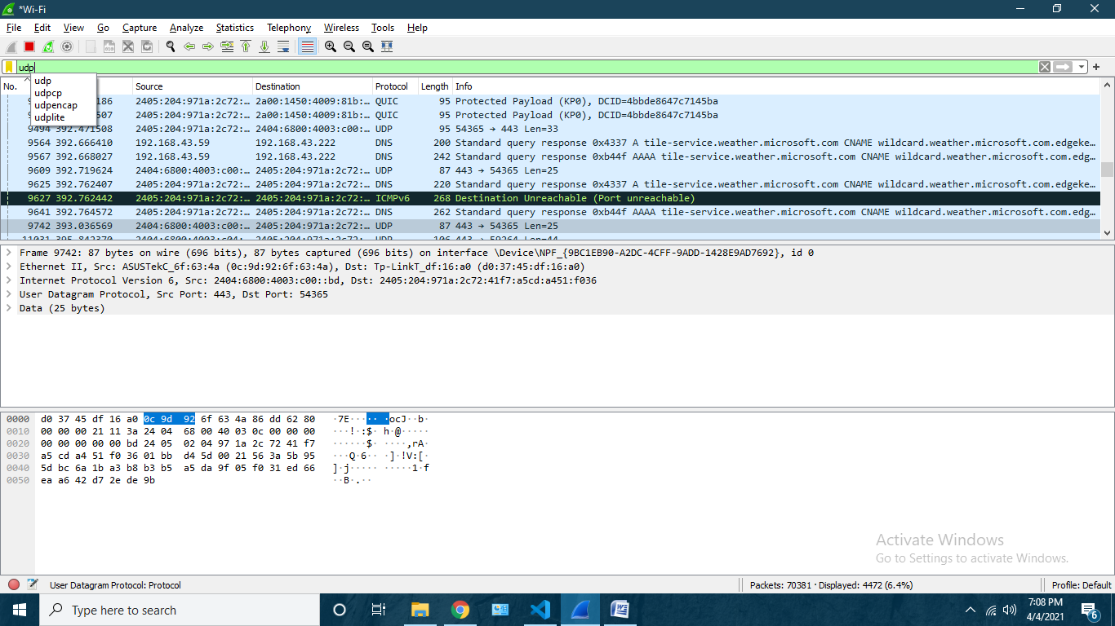

**FTP**

